|  |  |  |  |  |  |
| --- | --- | --- | --- | --- | --- |
| Date | 9-Dec-22 | | | Tester Name | Janette Paus |
| Environment | Penfax - Test 2 | | | Login used |  |
| Operating System | Windows | Version: 21H2 | Update Number: | | |
| Software Used | Select Software | Version: 107.0.1418.56 | Update Number: | | |
| Select Software | Version: | Update Number: | | |
| Application Release version | R22.4.1 | | | | |
| Test Case Title | E20.08b | | | | |
| Test Type | Regression | | | | |
| Test Scenario | Backdate a Payment | | | | |
| Expected Results | To process a payment that has a previous date to it (effective date a previous day). To check the breakage log to ensure it shows on the report and is reasonable.  To confirm that the unit values used in the payment were the ones on the effective date (not the process date) and that the funds/unit values used are effective the correct date.  Also confirm that the taxes are correct based on the amount withdrawn (for SMA/Lump Sum) even when the payment is backdated. | | | | |
| Pass/Fail | Pass | | | JIRA# |  |

Search for a deferred member

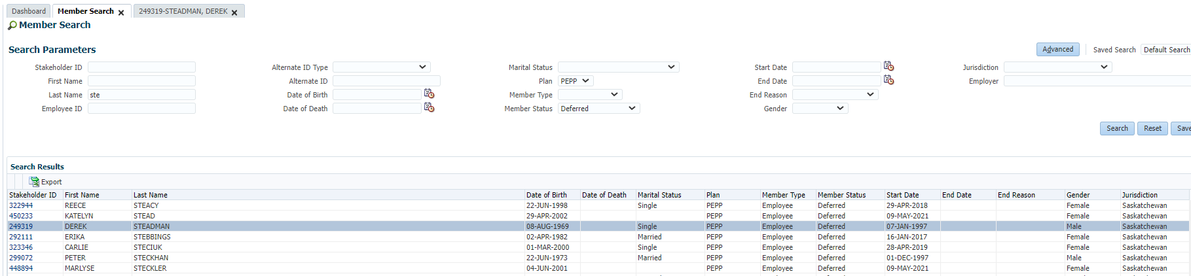

Ensure member has money in their PEPP account

SID 249319

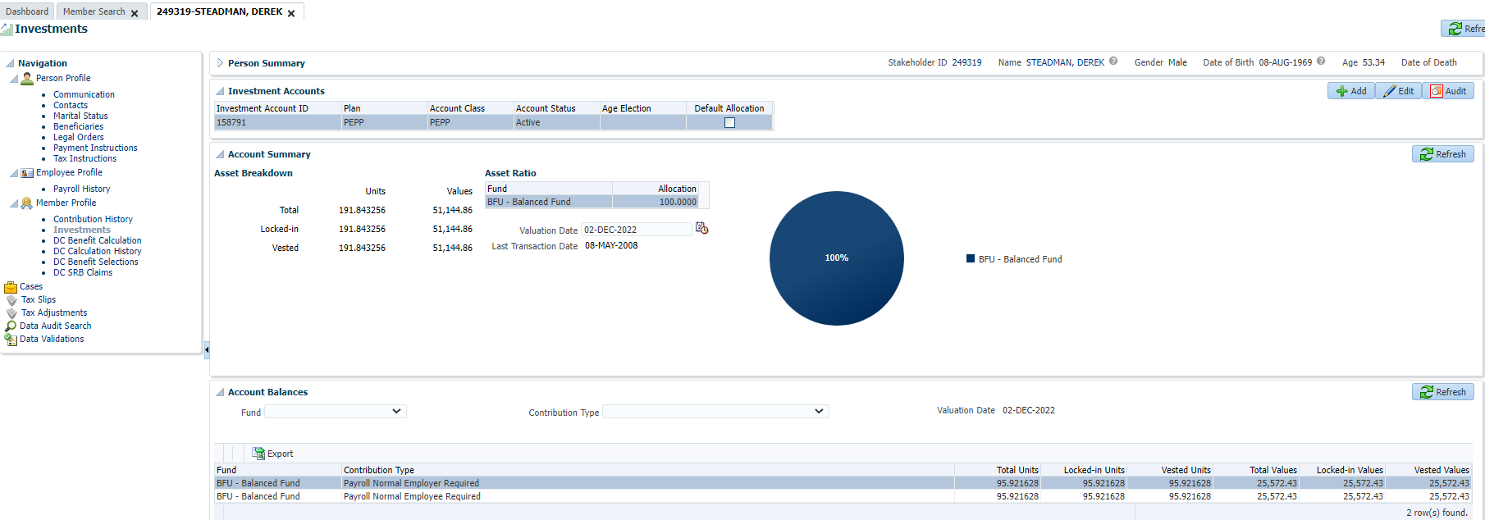

Add a DC Benefit Selection and enter in a date in Override Valuation Date and click Next

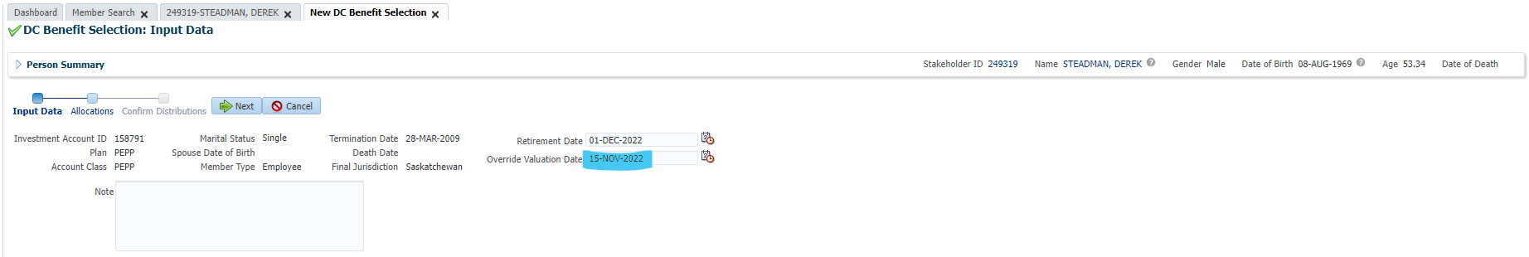

Enter type of payment and click Next

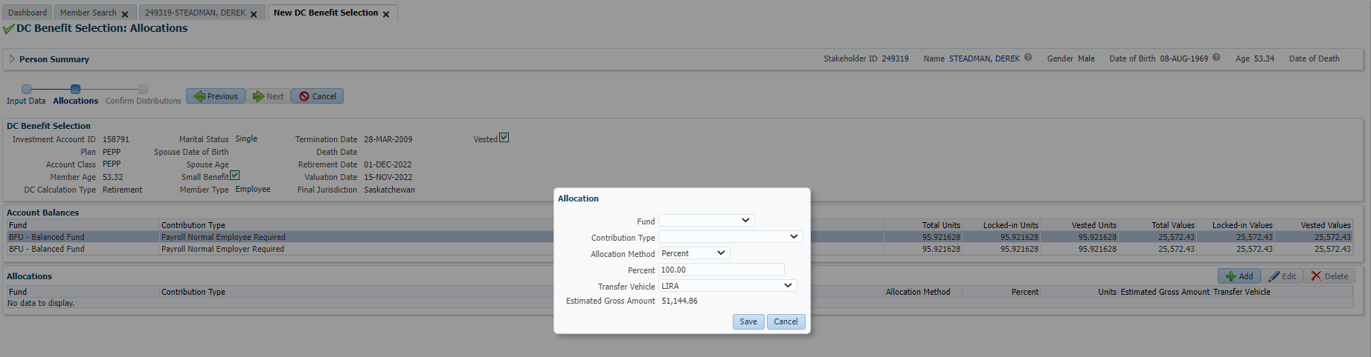

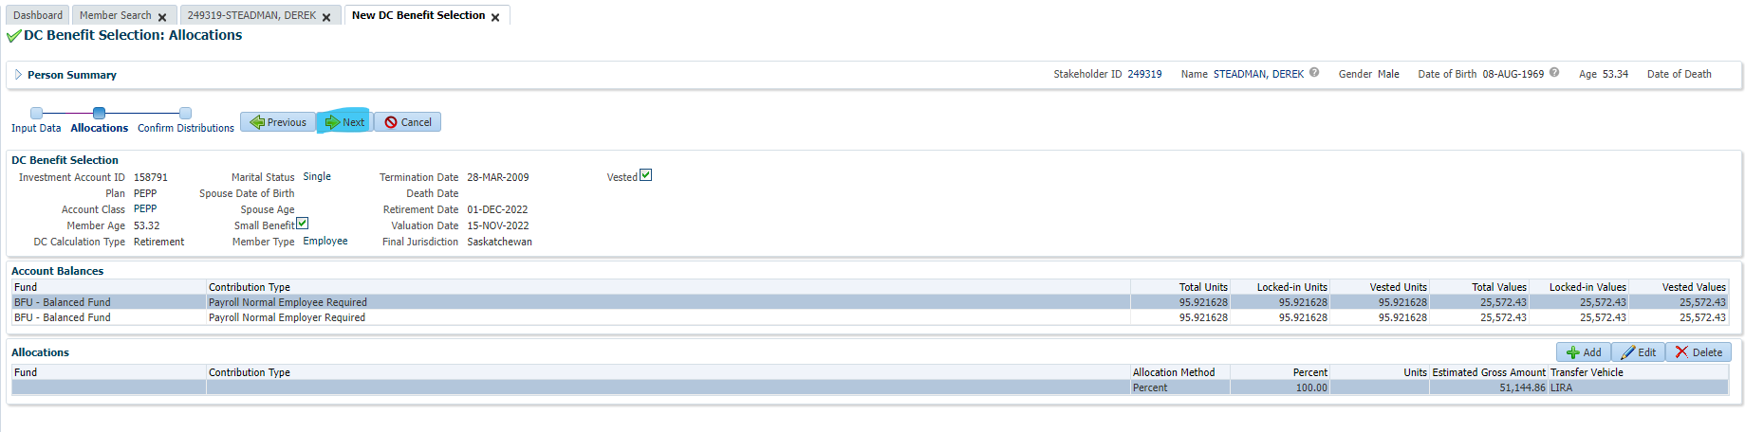

Add payment instructions and click submit for approval

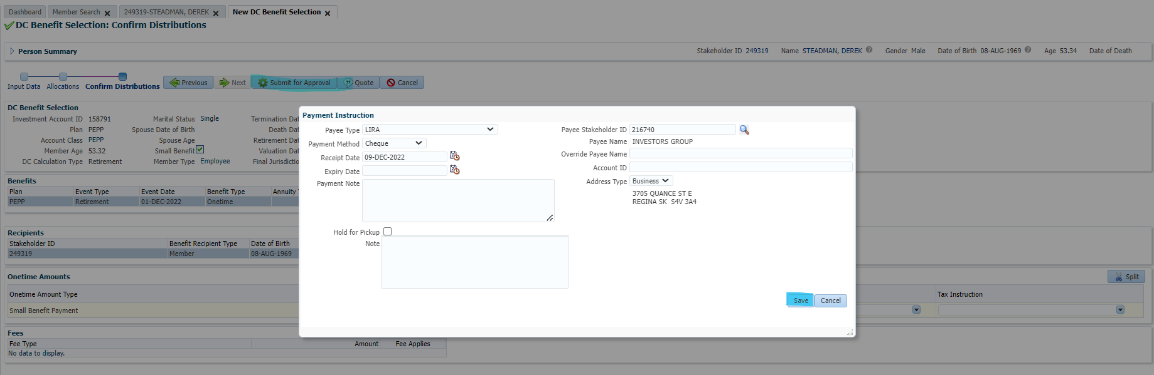

Click Approve

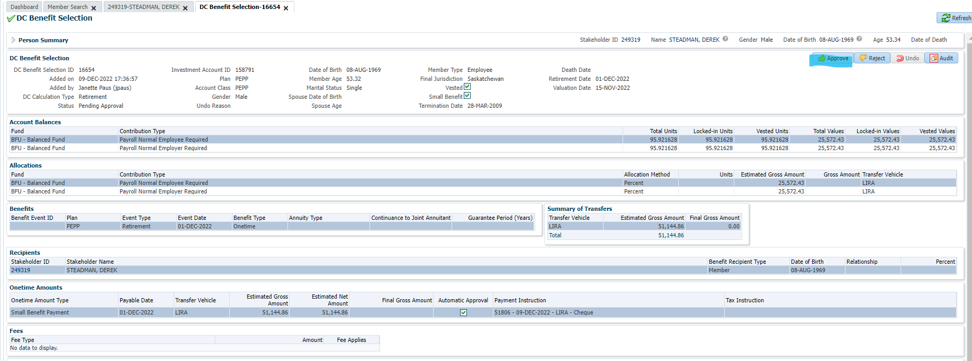

Next Day:

Confirm unit values were used as of the date used in the Override Valuation Date and that the payment processed correctly

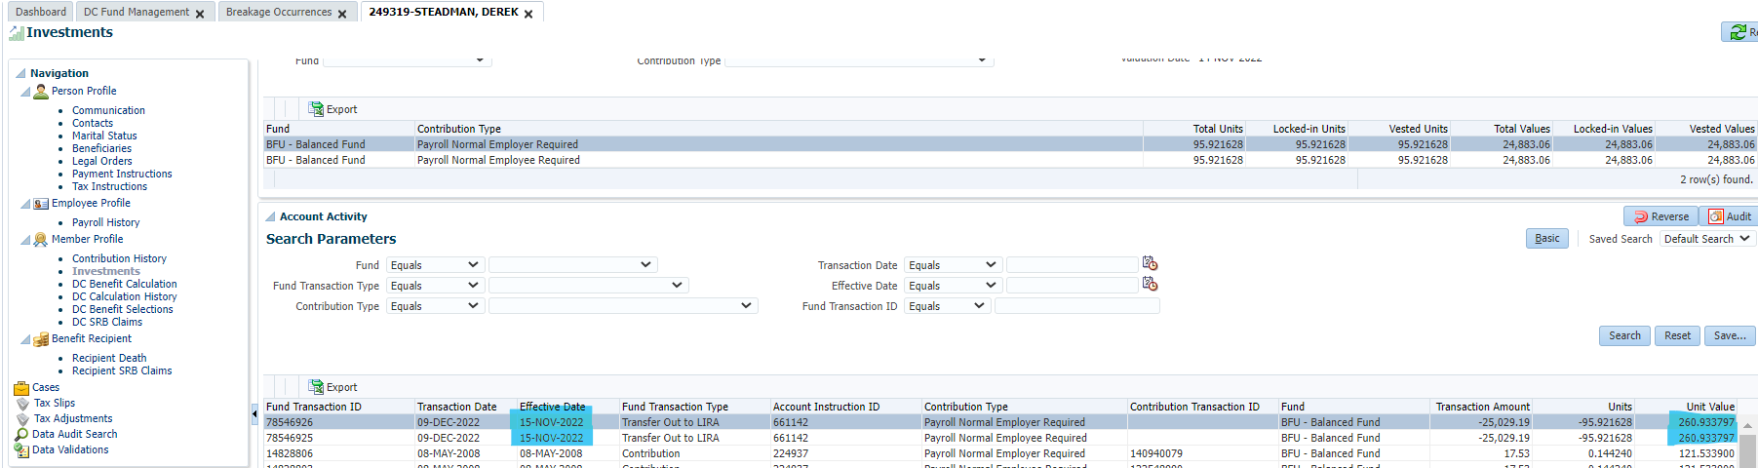

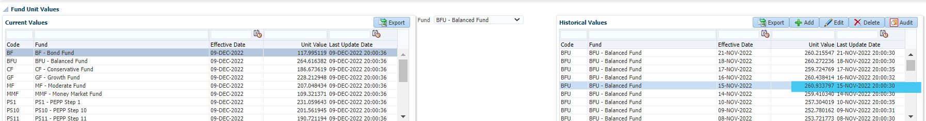

Confirm Breakage Calculation

Confirm Tax Calculation

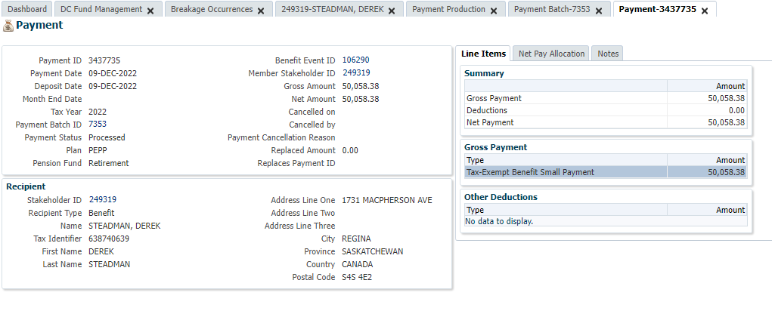

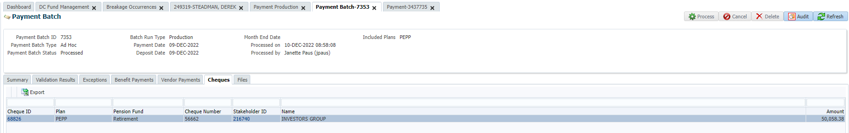

Small benefit gross payment is correct as this member does qualify for a small pension payment.

No tax deducted which is correct.

Payee name and cheque details are correct.